Unit 5 Part 1 –Review

Natural Selection vs. Selective Breeding
Natural selection is the process by which traits become more or less common in a population over many generations based on organism fitness (ability to survive and reproduce). This happens naturally over time and does not require the help of humans.
While Selective breeding (also called artificial selection or Unnatural selection) is the process by which humans breed other animals and plants for particular traits.

Example of natural selection:
1-In an ecosystem, some giraffes have long necks and others have short ones. If something caused low-lying shrubs to die out, the giraffes with short necks would not get enough food. After a few generations, the giraffes would have long necks.

2- Peacock females pick their mate according to the male’s tail. The ones with the largest and brightest tails mate more often. Today, males that do not have bright feathers are very rare.

Example of selective breeding:
1-Producing disease-resistant wheat by crossbreeding wheat plants with disease resistance and wheat plants with a high yield.

2-Increasing milk yield by selecting bulls from high yield herds and breeding them with cows that have the best milk production.

The diagram shows four animals that lived at different times. Fossil evidence indicates that each animal was an ancestor of the next one on the time line.
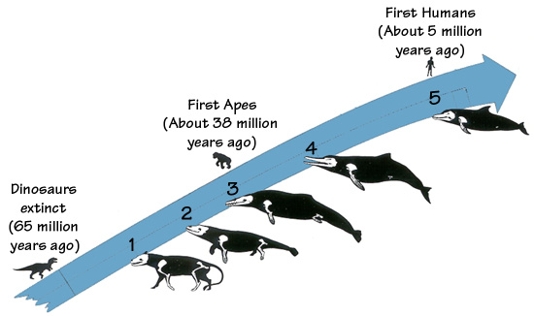
- Describe the environments of species 1 and 5 differ from one another.
__________________________________________________________________________________________________________________________________________________________
- Using the diagram above, explain what traits evolved overtime and why some traits were eliminated.
__________________________________________________________________________________________________________________________________________________________
- A farmer selectively breeds tomatoes to be shipped in a train to grocery stores all across the United States. The tomatoes need to be healthy when they arrive at the stores. Which of the following genetic traits would it be most important to selectively breed in the tomatoes?

A The flavor of the tomatoes
B The spoiling time of the tomatoes
C The appearance of the tomatoes
D The size of the tomato plants’ leaves

In order to survive and thrive in specific environments, animal species (along with plants and other organisms) have developed a host of amazing characteristics that help them find food, protect themselves, cope with tough environments, and reproduce. Some of these are physical characteristics — like sharp beaks, bright coloration, or body types that can take advantage of thermals (raise of warm air) and updrafts (upward current of air). Others are behavioral. These include building nests, communicating with one another, and ways of finding food.
Adaptations don't happen overnight; they are slow, gradual changes that can take hundreds of thousands of years to evolve. If an animal has a particular physical characteristic or behavior that enables it to survive when others in its species are less likely to, that trait gets passed onto its offspring and to future generations. This is referred to as evolution as a result of natural selection.
- Give an example of a structural (physical) adaptation: __________________________________________________________________________________________________________________________________________________
- Give an example of a behavioral adaptation:
__________________________________________________________________________________________________________________________________________________
- How does camouflage benefit an animal?
__________________________________________________________________________________________________________________________________________________
- Which of the following best explains the differences in colors and markings of a beetle?

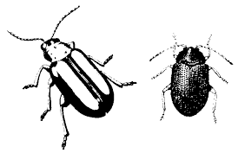
- They change their color or markings to match the environment, to hide from their prey or predator’s more easily.
- The food they eat changes their appearance over time.
- The markings help them blend into their environment to avoid predators and to survive long enough to reproduce and pass their genes onto future generations.
- The variation in their markings is so that they can recognize their own species in their environment.

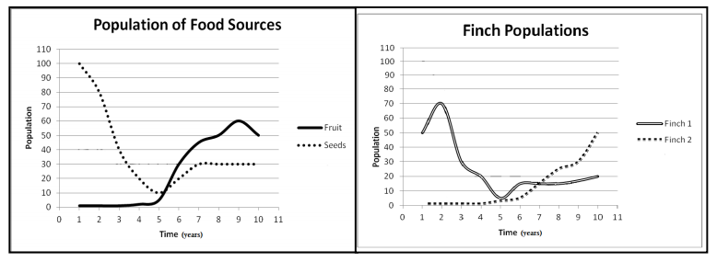

Analyze the graphs above. What happened to the seed and fruit population in the ten years recorded?

________________________________________________________________________

What happened to the Finch 1 and 2 populations in the ten years recorded?

________________________________________________________________________

Why Do Animals Migrate?
Migration is driven by a simple fact: Resources on Earth fluctuate (change). Warm summer months may be followed by inhospitable (uninviting) cold. Plants – or other meals – may be abundant, but only for a short time. It’s important to have available resources like food and water are essential for survival. Animals also migrate to find shelter, the best place to give birth or hatch young. Migration is done by instinct. It is a behavioral adaptation evolved over many thousands of years. The animals that responded to seasonal challenges by moving toward areas that had more food and other things they needed, were the ones that survived and passed on that "urge for going" to future generations!
How does migration help organisms survive?
___________________________________________________________________________
Key ideas to remember as you study:
- An adaptation is a genetic characteristic within a population that allows organisms to survive and reproduce. Adaptations occur to populations, not individual organisms. For instance, some migrate, others hibernate. Additionally, others may store fat and energy in order to stay through a cold winter.

- Adaptations can also be found in internal structures. The gills of a fish aid in filtering oxygen from water, the presence of hollow bones in birds decrease their weight so they use less energy in flight, and the xylem used to transport water from roots to higher structures in plants, these are all examples of internal adaptations.

Dichotomous Keys
Identify the common name of the 3 fish below.
- ____________________ 2. _____________________ 3. ______________________
