Unit 3 DCA Part 2 Review
Weathering, Erosion and Deposition
Define weathering __________________________________________________________________________________________________
Define erosion __________________________________________________________________________________________________
Define deposition __________________________________________________________________________________________________
Wind and water are the main agents of soil erosion. The amount of soil they can carry away is influenced by two related factors:
• Speed - the faster either moves, the more soil it can erode;
• Plant cover - plants protect the soil and in their absence wind and water can do much more damage.
Plants provide protective cover on the land and prevent soil erosion for the following reasons:
• Plants slow down water as it flows over the land (runoff) and this allows much of the rain to soak into the ground;
• Plant roots hold the soil in position and prevent it from being washed away;
• Plants break the impact of a raindrop before it hits the soil, thus reducing its ability to erode;
• Plants in wetlands and on the banks of rivers are of particular importance as they slow down the flow of the water and their roots bind the soil, thus preventing erosion.
The loss of protective vegetation makes soil vulnerable to being swept away by wind and water. In addition, over-cultivation (over harvesting of crops or plants) and compaction (process by which the porosity of a given form of sediment is decreased as a result of its mineral grains being squeezed together) cause the soil to lose its structure and solidity and it becomes more easily eroded. Erosion will remove the top-soil first. Once this nutrient-rich layer of soil is gone, few plants will grow in the soil again. Without soil and plants the land becomes desert-like and unable to support life.
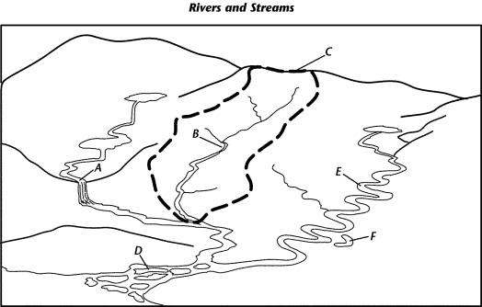
Use the following terms to label the diagram
Oxbow lake
River
Divide
Meander
Delta
Waterfall
A_________________________ B_________________________ C_________________________
D_________________________ E_________________________ F_________________________
What is surface water?

  - water that has not seeped into the ground and is exposed to the air
  - water that is under the ground in the Floridian aquifer
  - water that runs through the pipes in our homes
  - water that is at the bottom of the well

Wetlands plan an important role in watersheds. What is a wetland?

  - an area of land that is wet at least part of the year
  - an area of land where few plants and animals can live.

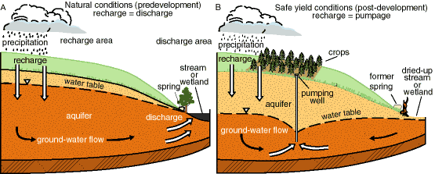

Describe what happened to the ecosystem above after a pumping well was implanted for crop production.
______________________________________________________________________________________________________________________________________________________________________________________________________________________________________________________________________________
If you were creating a model of the Aquifer shown above, what would you use to show fertilizer pollution seeping into ground water?

- Colored sand grains
- Water based food coloring
- A top layer of clay
- Cut up paper fragments

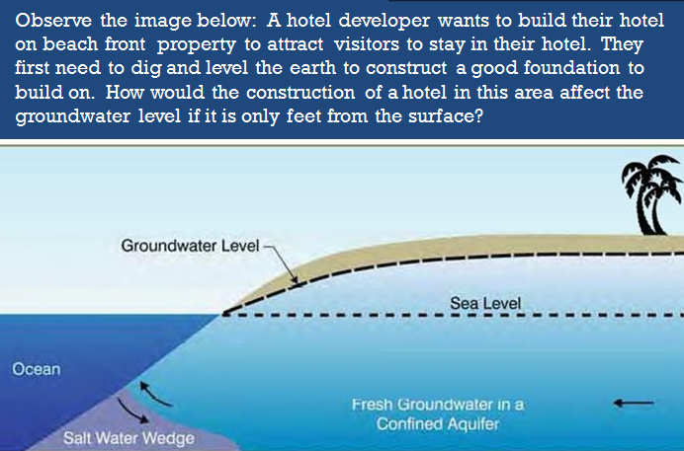
______________________________________________________________________________________________________________________________________________________________________________________________________________________________________________________________________________________________________
The diagrams below show some changes in an environmental community over time due to succession.
What is a community?
____________________________________________________________________________________________________________
What are the connections between natural resources, and the types of species in the community? (image to the left)
____________________________________________________________________________________________________________
What caused the change in the pond over time? Is this primary or secondary succession?
____________________________________________________________________________________________________________

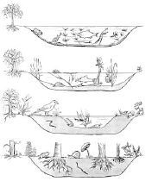
Time
Which phrase best describes this sequence of diagrams?
A. | the path of energy through a food web in a natural community
B. | the altering of an ecosystem by a natural disaster
C. | natural communities will change over time until the ecosystem is stable
D. | similarities between an aquatic ecosystem and a terrestrial ecosystem
Complete the table below by identifying form of succession, pioneer species and if the event occurs in Texas.
Event | Succession: Primary / Secondary / Both | Pioneer Species: Lichens and Moss/ Grasses and Weeds | Occurs in Texas: Yes / No
Forest fire
Earthquake
Plowing a field
Tornado
Flooding
Hurricane
Volcano | Primary Succession | Lichens and Moss | No
Deforestation
How does a Hurricane affect the coast?
- Storm surge brings an increase of salt water inland which disturbs freshwater ecosystems.
- It erodes the land by moving and removing sediments causing loss of plant and animals habitats.
- Removes vegetation and natural resources causing organisms to compete for survival.
- B and C only
- All of the above

