Assessment Review and Study Guide:
Effects of Catastrophic Events on Ecosystems and Weathering, Erosion and Deposition
Catastrophic Events Impact on Ecosystems
Floods
- When flood happen very quickly they are called ______________________________.
Environmental Impact of Floods
- Floods are important in maintaining ecosystem ___________________________________________fertility.
- Human attempts at managing flood prone areas ____________________ the natural flood cycle.
Negative Effects of Flooding | Positive Effects of Flooding
- Floods destroy drainage systems causing raw sewage to spill out into bodies of water.  - Buildings can be destroyed which can lead to many toxic materials such as paint, pesticide and gasoline being released into the rivers, lakes, bays, and ocean, killing marine life.  - Floods cause significant amounts of erosion to coasts, leading to more frequent flooding if not repaired. | - Floods positively impact the environment by spreading sediment containing nutrients to topsoil.  Plants  - On dry land, plant life can benefit from the sudden appearance of a large quantity of flood water.  - Water stored underground will be replenished by the floodwater, while soil above ground will be able to soak up the water.  - Plants will be able to receive water as a result. Flood water may prove a new lease on life for an area.  - The soil is likely to be more fertile, leading to a suitable area in which to grow crops.  - The nutrients carried by the flood water can also revive deprived plants and aid in the germination of seeds.
Vocabulary

Pesticide- not just insect killer. It can also include chemicals to control weeds, rodents, mildew, germs, and more.
Germination is the process by which a plant grows from a seed.

- Describe two ways plants benefit from flood waters? Describe in your own words.
______________________________________________________________________________________________________________________________________________________________________________________________
Hurricanes
- Where do hurricanes form? _____________________________________________________________________
How Hurricanes Affect the Ecosystem
- Aquatic Ecosystems
  - Sediment erosion and deposition often affect oyster beds and coral reefs.
- How does saltwater affect freshwater lakes and streams? ___________________________________________________________________________________________

- Hurricanes have minimal effect on oceanic ecosystems since the contaminants tend to be __________________ by tidal flows.
- Terrestrial (land) Ecosystems
  - Coastal wetlands and barrier islands take the brunt of the storm surge.
  - Many barrier islands end up shifted or eroded below sea level.
  - Saltwater interference from storm surge also changes the wetland ecosystems by _____________________________ that are critical to feeding and nesting many animals.
Tornadoes Effect on Ecosystems
- Over what surface do tornadoes form?___________________________________________________________

- Vegetation is uprooted.
- Trees can be pulled out of the ground and carried to another location.
- This can cause a __________________________________________ of organisms that could also affect the interaction between plants and animals.
- The loss of plants caused by a tornado can allow ______________________________________ species of plants to grow in the cleared area.
- This loss of vegetation could also lead to __________________________.
Droughts affect the environment in many different ways. Plants and animals depend on water, just like people. When a drought occurs, their food supply can shrink and their habitat can be damaged. Sometimes the damage is only temporary and their habitat and food supply return to normal when the drought is over. But sometimes drought's impact on the environment can last a long time, maybe forever.
Examples of environmental impacts due to Drought include:

- Lack of _____________ and drinking water for wild animals
- Migration of _________________
- Loss of _________________
- More ______________________
- Poor ______________ quality
- Wind and water erosion of soils

- What is the most common of all natural hazards? (circle your response) Tornado Hurricane Flooding Drought
- Which catastrophic event would most likely cause a storm surge? _____________________________________
- How do Tornadoes and Hurricanes pose a negative effect on plants?
___________________________________________________________________________________________
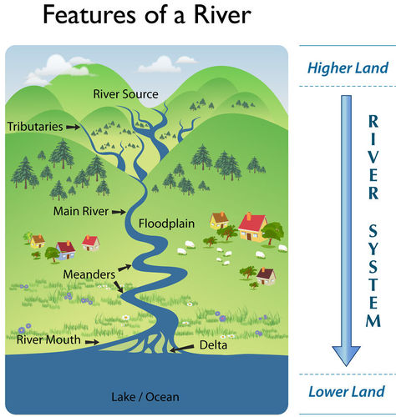
Weathering, Erosion and Deposition
Meanders are curves found in the middle and lower course of a river caused by erosion and deposition and the change in speed of water causes the meanders. However, the geology of the land means a river will rarely flow in a straight path so this is why it will meander. Combination of the erosion and deposition helps expand the size of the meander. Eventually this can lead to the formation of an oxbow lake.
- How are meanders formed?(use term erosion and deposition)
__________________________________________________________________________________________________________________
- How is a delta formed?(use term deposition)
__________________________________________________________________________________________________________________
- How does river rock get its smooth surface? What form of mechanical weathering occurs?
____________________________________________________________________________________________________________________________________________________________________________________________________
- How is the rock in question 11 weathered physically over time? _______________________________________
As the water erodes the banks of the river, sediments are picked up and deposit down the river in a new location. Place the eroding sediments in order of furthest to shortest traveled downstream. (sand, pebbles, silt, rocks)
Furthest ____________________, ____________________, ____________________, ____________________Shortest
Which form of sediment will reach the mouth of the river in the shortest amount of time during high rains?
Rock 8 mm and larger
Pebble <8mm
Sand <2 mm
Silt <1/16th mm
Clay <1/256th mm

Loam ? soil that is made up of equal parts of
sand, silt, and clay
Claim: I claim that sediments of _________________will travel the furthest distance in the shortest amount of time to the mouth of the river, and help form the delta, because __________________________________________________________________________
__________________________________________________________________________
Evidence: __________________________________________________________________
__________________________________________________________________________
Reasoning: ____________________________________________________________________________________________________________________________________________________________________________________________________

